05-01-2017
- When click on 'S13', a report of last 5 years handicap (Asian handicap and over/under) statistics will be displayed. It also displays a report of last 5 years handicap statistics for the selected league.
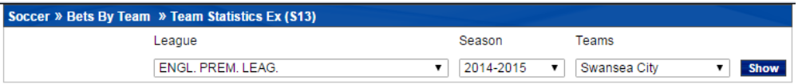
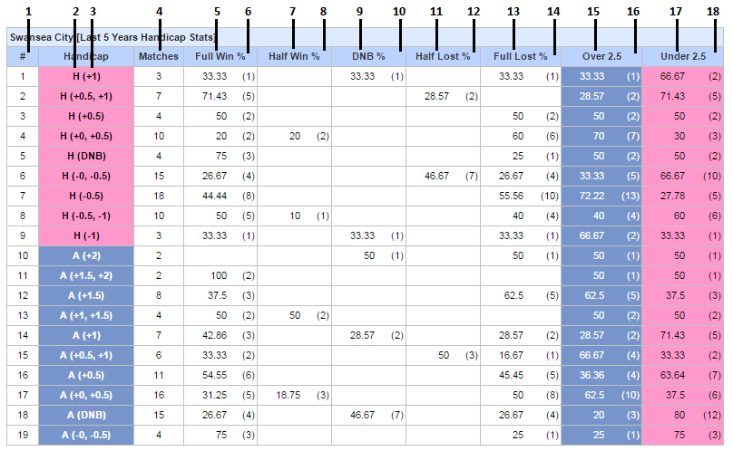
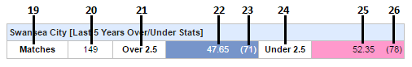

# | Header | Info
1 | Serial No.
2 | Team Name | Name of the team (In Header) for which statistics is shown
3 | Handicap | H -1-9 - fulltime Asian handicap when team played as Home  A -10-19 - fulltime Asian handicap when team played as Away
4 | Matches | Matches played (count)
5 | Full Win% | (nFullWinCount / nTotalPlayed) * 100
6 |  | Full Win match count
7 | Half Win% | (nHalfWinCount / nTotalPlayed) * 100
8 |  | Half Win match count
9 | DNB% | (nDNBCount / nTotalPlayed) * 100
10 |  | DNB match count
11 | Half Lost% | (nHalfLoseCount / nTotalPlayed) * 100
12 |  | Half Lost match count
13 | Full Lost% | (nFullLoseCount / nTotalPlayed) * 100
14 |  | Full Lost match count
15 | Over 2.5 | Over handicap
16 |  | Over 2.5 match count
17 | Under 2.5 | Under handicap
18 |  | Under 2.5 match count
19 | Matches | Total matches
20 |  | Total no. of match count
21 | Over2.5 | Over Handicap
22 |  | Over 2.5 percentage from all matches
23 |  | Total match count with score over 2.5
24 | Under2.5 | Under Handicap
25 |  | Under 2.5 percentage from all matches
26 |  | Total match count with score under 2.5

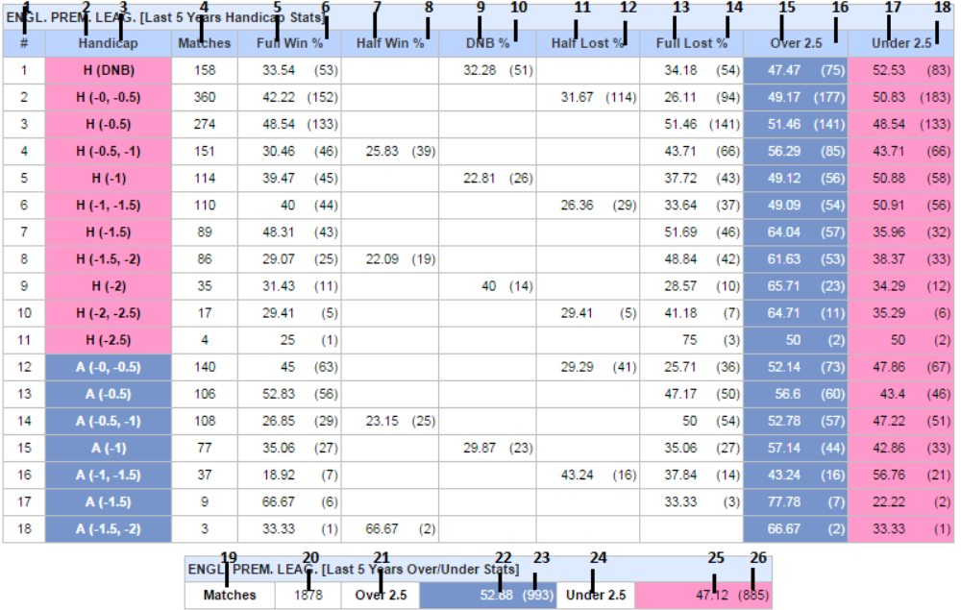

# | Header | Info
1 | #. | Serial No
2 | H , A | Home team , Away team
3 | Handicap | fulltime Asian handicap of team A and team B
4 | Matches | Matches played (count)
5 | Full Win% | (nFullWinCount / nTotalPlayed) * 100
6 |  | Full Win match count
7 | Half Win% | (nHalfWinCount / nTotalPlayed) * 100
8 |  | Half Win match count
9 | DNB% | (nDNBCount / nTotalPlayed) * 100
10 |  | DNB match count
11 | Half Lost% | (nHalfLoseCount / nTotalPlayed) * 100
12 |  | Half Lost match count
13 | Full Lost% | (nFullLoseCount / nTotalPlayed) * 100
14 |  | Full Lost match count
15 | Over 2.5 | Score value that is over 2.5
16 |  | Over 2.5 match count
17 | Under 2.5 | Score value that is under 2.5
18 |  | Under 2.5 match count
19 | Matches
20 |  | Total no. of matches played
21 | Over2.5 | Over handicap
22 |  | Percentage of matches with Over 2.5
23 |  | Total matches count with Over 2.5
24 | Under2.5 | Under handicap
25 |  | Percentage of matches with Under 2.5
26 |  | Total matches count with Under 2.5

